# Logging in

Expected input: username = ‘admin’ and password = ‘qQ1@’ (or string in passwd.json)

Figure 1.1 Wrong password

Figure . Wrong username

Figure . Correct password and username

# Menu

Expected input: valid integer between 1 and 5

Figure . Input blank

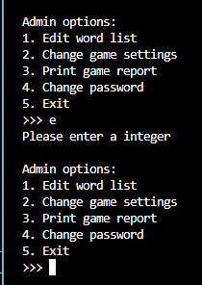

Figure . Input letter

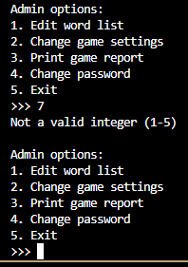

Figure . Input integer outside valid range

Figure . Input valid integer

# Edit word list

Expected input: integers between 1 to 6

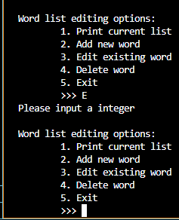

Figure . Input letter

Figure . Input integer out of range

Figure . Input '1' (print word list)

Figure . Entering '5' (exit word list editing)

## 3.1 Add new word

Expected input (entering new word): word (containing only letters or “ ‘ “) that isn’t already in list

Expected input (entering meaning): consist of character (no space only)

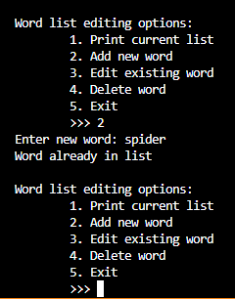

Figure ..1 Input word that already exist

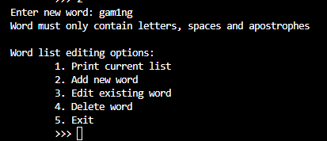

Figure .5.2 Word that contains invalid characters



Figure .5.3 Input valid word (< 10 letters)

Figure .5.4 Input valid word (>= 10 letters)

Figure .5.5 Input blank for meaning

Figure .5.6 Input text for meaning

## 3.2 Editing existing word

Expected input (selecting word to edit): word that is in word list

Expected input (selecting what portion to edit): ‘w’ or ‘m’

Expected input (editing word): word (containing only letters or “ ‘ “) that isn’t already in list

Expected input (editing meaning): consist of character (no only space)

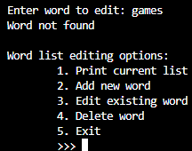

Figure ..1 Entering word not in word list

Figure .6.2 Entering a word that is in word list

Figure .6.3 Entering invalid option

Figure .6.4 Entering 'w' when selecting option

Figure .6.5 input 'm' when selecting option

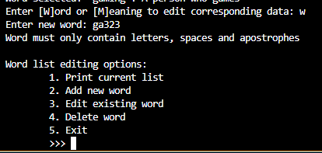

Figure .6.6 Entering word with invalid characters

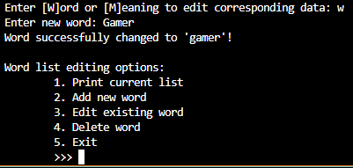

Figure .6.7 Entering valid word

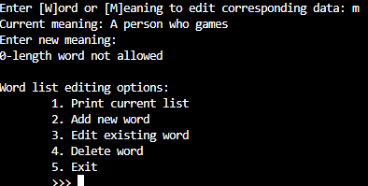

Figure .6.8 Entering space for new meaning

Figure .6.9 Entering characters for new meaning

## 3.3 Deleting word

Expected input (selecting word): word that is in word list

Expected input (confirmation): ‘y’ to delete, anything else to cancel

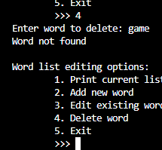

Figure ..1 input word not in list



Figure .7.2 Input word in word list

Figure .7.3 Entering letter that is not 'y' in confirmation

Figure .7.4 Input integer in confirmation

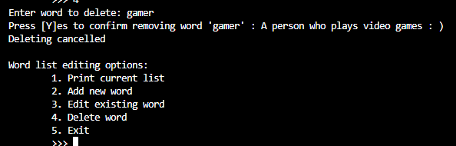

Figure .7.5 Input special character in confirmation

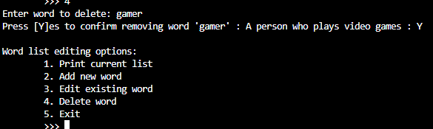

Figure .7.6 Input 'y' for confirmation

## 3.5 Create empty list

Expected input: ‘Y’ to confirm, anything else cancel

Figure ..1 Input other than 'Y'

Figure .8.2 Input ‘y’ to confirm

# Change game settings

Expected input (selecting settings): integer between 1 and 5

Expected input (entering new value): positive integer

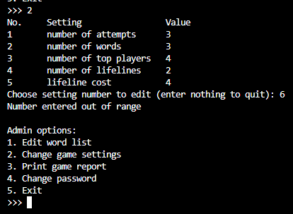

Figure . Input integer out of range

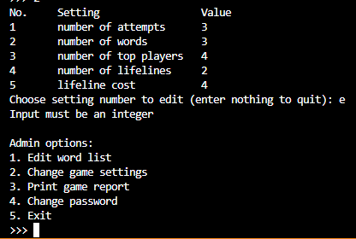

Figure . Input letter

Figure . Input spaces

Figure . Input integer in range

Figure . Input letters

Figure . Input negative integer

Figure . Input positive integer

# Print game report

Expected input: dates in DD/MM/YYYY format (values are numbers), or blank

Figure . entering letters

Figure . Input end date later than start date

Figure . Input nonexistent date

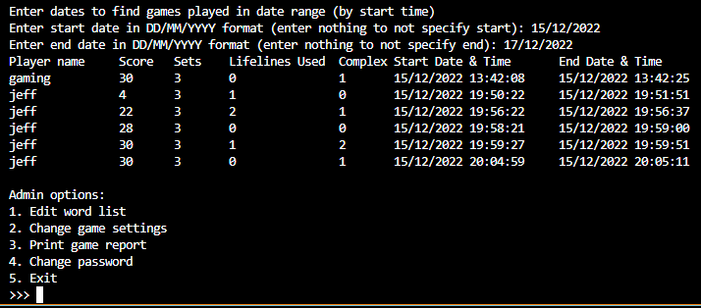

Figure . Input valid start and end dates

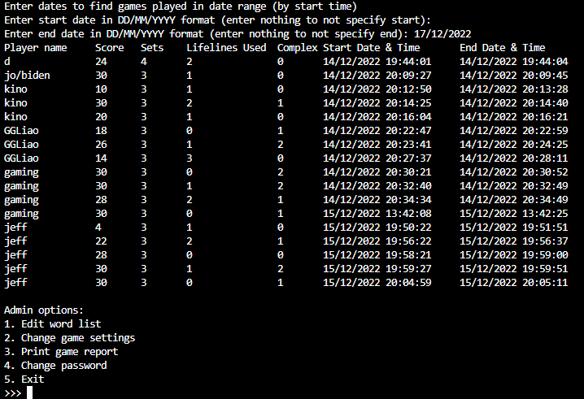

Figure . Input blank for start date

Figure . Input blank for end date

Figure . If no games are played in date range

# Change password

Expected input (new password): string length 4-20, and at least 1 of: uppercase, lowercase, number, valid special character (!@#$%)

Expected input (re-enter): same as new password

Figure . input nothing

Figure . input less than 3 characters

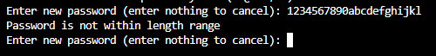

Figure . Input more than 20 characters

Figure . Input without valid special characters

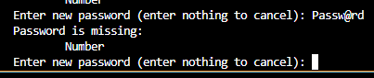

Figure . Input without numbers

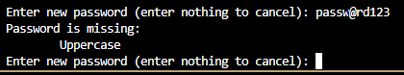

Figure . Input without uppercase letter

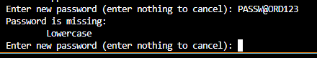

Figure . input missing lowercase letter

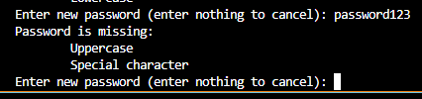

Figure . input missing multiple requirements

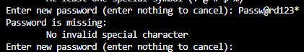

Figure . Input contains invalid special characters



Figure . input with all requirements

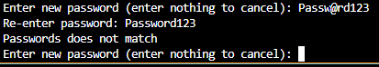

Figure . Re-enter does not match first input

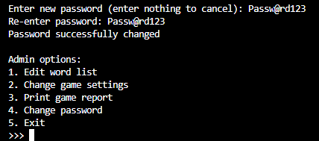

Figure . Re-enter matches first input